Page number:1
1,2,3,4,5,6,7,8,9,10,11,12,13,14,15,16,17,18,
19,20,21,22,23,24,25,26,27,28,29,30.
Page number:2
Do it yourself
Page number:3
Ten,nineteen,two,seven
Three,twelve,eighteen,one
Fifteen,four, eleven, eight
Five, thirteen, nine,sixteen
Twenty, six, fourteen ,seventeen
Page number:4
2,4,6,7
10,12,14,15
18,20,22,23
26,28,30,31
34,36,38,39
42,44,46,47
Page number:5
12 13 14 9 10 11
15 16 17 13 14 15
10 11 12 18 19 20
14 15 16 11 12 13
16 17 18 19 20 21
8 9 10 17 18 19
Page number:6
93 94 95 86 87 88
78 79 80 71 72 73
62 63 64 67 68 69
11 12 13 18 19 20
95 96 97 90 91 92
25 26 27 37 38 39
32 33 34 43 44 45
56 57 58 67 68 69
55 56 57 63 64 65
Page number:7
22 13
26 23
19 6
14 9
Page number:8
14 1
8 17
11 4
5 6
Page number:9
21 56 14 72
48 91 79 20
13 54 40 42
100 37 65 81
Continue the pattern
33 34 35
Page number:10
11 19
15 14
4 6
9 5
Page number:11
Thirty seven
Eighty five
Sixty two
Forty two
Seventy nine
Eighty nine
Page number:12
Sixteen
Twenty nine
Thirty five
Forty eight
Forty nine
Fifty two
Sixty eight
Seventy five
Page number:13
1 | 2 | 3 | 4 | 5 | 6 | 7 | 8 | 9 | 10
11 | 12 | 13 | 14 | 15 | 16 | 17 | 18 | 19 | 20
21 | 22 | 23 | 24 | 25 | 26 | 27 | 28 | 29 | 30
31 | 32 | 33 | 34 | 35 | 36 | 37 | 38 | 39 | 40
41 | 42 | 43 | 44 | 45 | 46 | 47 | 48 | 49 | 50
51 | 52 | 53 | 54 | 55 | 56 | 57 | 58 | 59 | 60
61 | 62 | 63 | 64 | 65 | 66 | 67 | 68 | 69 | 70
71 | 72 | 73 | 74 | 75 | 76 | 77 | 78 | 79 | 80
81 | 82 | 83 | 84 | 85 | 86 | 87 | 88 | 89 | 90
91 | 92 | 93 | 94 | 95 | 96 | 97 | 98 | 99 | 100

Page number:14
17 | 18 | 19 | 20 | 21 | 22 | 23 | 24 | 25 | 26
27 | 28 | 29 | 30 | 31 | 32 | 33 | 34 | 35 | 36
37 | 38 | 39 | 40 | 41 | 42 | 43 | 44 | 45 | 46
47 | 48 | 49 | 50 | 51 | 52 | 53 | 54 | 55 | 56
57 | 58 | 59 | 60 | 61 | 62 | 63 | 64 | 65 | 66

Page number:15
86 87 88 89 90 91
49 50 51 52 53 54
92 93 94 95 96 97
64 65 66 67 68 69
69 70 71 72 73 74
Page number:16
- (B)
Ten 10
Ninety 90
Thirty 30
Fifty 50
Forty 40
Twenty 20
Eighty 80
Seventy 70
Page number:17
53 54 55 24 25 26
17 18 19 44 45 46
50 51 52 9 10 11
68 69 70 17 18 19
80 81 82 71 72 73
1 2 3 84 85 86
15 16 17 87 88 89
88 89 90 97 98 99
64 65 66 27 28 29
Page number:18
Do it yourself
Page number:19
Do it yourself
Page number:20
- (B)
Nine 9
Five 5
Two 2
Six 6
Four 4
Three 3
Eight 8
Seven 7
Page number:21
A
61 sixty one | 10 ten
83 eighty three | 89 eighty nine
95 ninety five | 37 thirty seven
48 forty eight | 74 seventy four
99 ninety nine | 55 fifty five
25 twenty five | 87 eighty seven
B
89
72
38
19
60
77
Page number:22
9 ,10 ,12 ,15 9 ,13 ,18, 20
Page number:23
12 11 10 9
4 3 2 1
24 23 22 21
Page number:24
22 23 24 25
13 14 15 16
33 34 35 36
46 47 48 49
51 52 53 54
59 60 61 62
66 67 68 69
Page number:25
10,27,38,65
5, 27, 40, 50 18,27,41,40
Page number:26
4 3 2 1
2 3 1 4
1 2 3 4
Page number:27
58 39 25 12 65 38 27 10
50 40 27 5 49 41 27 18
Page number:28
12 Twelve
18 Eighteen
Page number:29
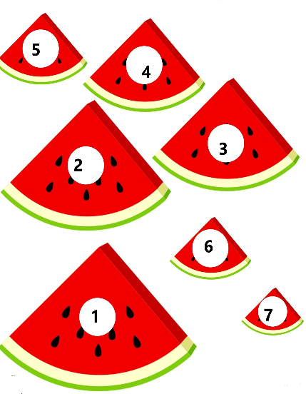
Page number:30
2. 11
3. 3 tens+ 3 ones =33
4. 4 ten + 3 ones = 43
5. 6 ten + 9 ones = 69
6. 7 ten + 0 ones = 70
7. 8 ten + 3 ones = 83
8. 6 tens + 0 ones= 60
9. 5 ten + 0 ones = 50
Page number:31
- 64 2) 32
3)48 4) 15
5) 71 6)93
7) 26 8) 50
Page number:32
52
61
57
52
31
Page number:33
40 + 3 = 4 tens +3 ones
10 + 2 = 1 tens + 2 ones
20 + 4 = 2 tens + 4 ones
40 + 5 = 4 tens + 5 ones
80 + 7 = 8 tens + 7 ones
90 + 8 = 9 tens + 8 ones
50 + 5 =5 tens +5 ones
70 + 8 = 7 tens +8 ones
80 + 9 = 8 tens + 9 ones
Page number:34
1 2 3 4 5
6 7 8 9 10
11 12 13 14 15
16 17 18 19 20
21 22 23 24 25
26 27 28 29 30
31 32 33 34 35
36 37 38 39 40
41 42 43 44 45
46 47 48 49 50

Page number:35
4 tens 5 ones 3 tens 4 ones
5 tens 2 ones 4 tens 6 ones
2 tens 5 ones 6 tens 7 ones
3 tens 5 ones 9 tens 0 ones
4 tens 5 ones 5 tens 1 ones
6 tens 8 ones 6 tens 2 ones
Page number:36
2 3 4 5 6 7 8
2 4 6 8 10 12 14
2 5 8 11 14 17 20
2 6 10 14 18 22 26
2 7 12 17 22 27 32
2 8 14 20 26 32 38
2 9 16 23 30 37 44
Page number:37
Smallest number largest number
11 17
23 38
15 91
39 31
1 78
26 58
41 74
14 91
14 58
36 71
Page number:38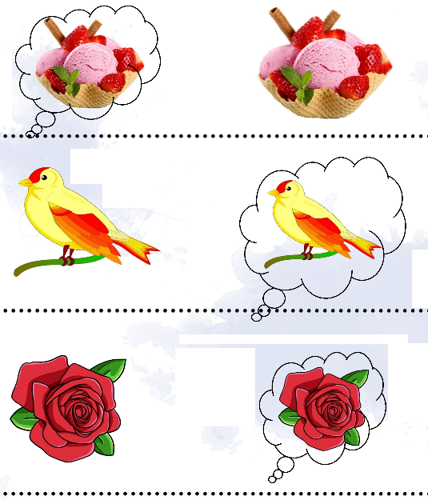
Page number:39
Total number of pineapples =24
Page number:40
a) just after 7
b) just after 4
c ) just after 5
d) just after 8
e) just after 2
f) just after 6
g) just after 1
h) just after 0
Page number:41
1. correct is
15+5=20 , 27+7=34 , 25+9 = 34
2. ADD
40 40 110 54
90 174 88 65
87 134 99 100
Page number:42
1) 5 + 1= 6 2) 3+2=5 3)4+4=8
4) 4+3=7 5) 2+5=7 6) 3+3=6
7) 5+5=10 8) 6+2=8 9) 3+6=9
10) 4+6=10 11) 6+5=11 12) 5+4=9
Page number:43
1+2=3 3+6=9
4+4=8 5+5=10
5+6=11 4+6=10
Page number:44
1. 9+2=11
2. 8+6 =14
3.4+2=6
4. 4+4=8
5. 8+2=10
6. 13+6=19
7. 11+2=13
8. 12+2=14
9.1+5=6
10. 7+2=9
Page number:45
2. seven
3. two
4. nine
5. eighteen
6. eighteen
7. twelve
8. fifteen

Page number:46
Rs. 35
Rs.15
4 bats
Rs. 10
Rs 60
Page number:47
>
>
=
=
>
>
Page number:48
1) 3 2) 5 3) 5 4) 4 5) 5
Page number:49
13+3=16
10+6=16
12+4=16
15+1=16
9+7=16
Page number:50
6 | 3
5 | 6
11 | 2
3 | 8
4 | 8
6 | 7
6 | 8
8 | 3
10 | 4

Page number:51
1) 24+24= 48 2) 16+23=39 3)27+14=41 4) 21+16=37
5) 16+28=44 6) 32+16=48
Page number:52
6 12
17 19
11 5
14 12
10 11
11 13
14 11
13 12
12 10
Page number:53
7 10
5 1
9 2
3 4 8 6
SNOWMAN
Page number:54
87=88-1 15=14+1
35=36-1 93=92+1
65=64+1 10=11-1
45=44+1 49=50-1
95=96-1 75=74+1
45=44+1 84=85-1
68=69-1 94=93+1
29=28+1 89=90-1
39=38+1 100=101-1
79=80-1 51=50+1
Page number:55
3 4 5 17 18 19
6 7 8 26 27 28
2 3 4 32 33 34
4 5 6 40 41 42
8 9 10 28 29 30
10 11 12 31 32 33

Page number:56
Do it yourself
Page number:57
120 34 69
22 14 26
11+9=20 14-4=10
4+8=12 19-4=15
8+7=15 0-3=3
3+3=6 20-2=18
Page number:58
6 marbles
5 kites
4 mugs
5 apples
2 pages
Page number:59
Do it yourself
Page number:60
faces | Edges | Vertices]
5 | 8 | 5
1 | 2 | 1
6 | 12 | 8
1 | 0 | 0
5 | 9 | 6
3 | 2 | 2

Page number:61
Do it yourself
Page number:62
roll | slide | Stack
no | yes | Yes
yes | no | No
no | yes | Yes
yes | yes | No
no | yes | Yes
Yes | yes | yes

Page number:63
Do it yourself
Page number:64
Do it yourself
Page number:65
2. 5+3=8 , 3+5=8, 8-3=5, 8-5=3
3 2+3=5 , 3+2=5, 5-3=2, 5-2=3
4 6+3=9, 3+6=9, 9-3=6, 9-6=3
Page number:65
2 inches
5 inches
7.5 inches
7 inches
Page number:66
1) 3,2,1 2) 3,1,2
3) 2,3,1 4) 1,3,2
5) 1,3,2 6) 3,2,1
7) 3,1,2 8) 2,1,3
Page number:68
4 blocks 6 blocks 9 blocks
Page number:69
1) 8 lady bug 2) 18 lady bug 3)12 lady bug
Page number:70
5c.m
3 c.m
6 c.m
Page number:71
Bucket
Pan
pot
Page number:72
Do it yourself
Page number:73
Do it yourself
Page number:74
Friday Saturday Sunday
Thursday Friday Saturday
Saturday Sunday Monday
Tuesday Wednesday Thursday
Sunday Monday tuesday
Page number:75
1) 1 2) 3 3) 2 4)2 5)3
Page number:76
Monday
Tuesday
Wednesday
Thursday
Friday
Saturday
Sunday
There are 7 days in a week.Sunday is a holiday.
Page number: 77
>

>
>
>
>
<
Page number: 78
Rs. 21
Rs. 6
Rs. 7
Rs. 5
Rs. 14
Page number: 79
- 12
- 9
- 7
- 6
- 4
Page number: 80
Elephant
Horse
Bear and horse
1 animal
Horse and rhinoceros

Page number: 81
Rs. 40 Rs. 90
Rs.38 Rs. 70
Rs.35 Rs.85
Page number: 82
Rs.20+ Rs.10+ Rs.10+ Rs.5
Rs.10 + Rs 10
Rs. 20 +Rs.10 +Rs.5 +Rs.2
Page number: 83
Aaron’s bill
Rs7+Rs18+Rs.12+Rs.40=Rs.77
Abel’s bill
Rs35+Rs.20+Rs25+Rs.14=Rs.94
Abel’s bill is more by Rs17
Page number: 84
Square- 2
Triangles- 4
Rectangle -7
Circle-8
Page number: 85
IIIII
III
II
Page number: 86
Do it yourself
Page number: 87
Do it yourself
Page number: 88
Do it yourself
Page number: 89
Star fish 3 dolphin 3 sea horse 5
Turtle 3
Page number: 90
24
72
16
40
Page number: 91
22 05 06
22 22 54
x 39 06
32 20 60
Page number: 92
Do it yourself
Page number: 93
2,1,3,4
3,2,4,1
1,2,3,4
Page number: 94
1) 4 2) 2 3) 3 4) 1 5) 3
Page number: 95
1) Gloria 2) Jessica 3) 20
4) Gloria 5) 2
Page number: 96
Do it yourself
Page number: 97
1) A.M 2) P.M 3) P.M 4) A.M
5) A.M 6) P.M 7) A.M 8) P.M
Page number: 98
Cherry
Rose
toffee
Page number: 99
14-8=6
3-2=1
6-3=3
Page number: 100
A)
1) 4 2)3 3)4x3=12 4)12
B)
1)2 2)2 3)2x2=4 4)4

